Employee Sentiment Analysis Report

Sentiment Labeling Method
Used TextBlob polarity with thresholds ±0.1 to classify Positive/Negative/Neutral.
Dataset Summary
Total messages: 2191
Total employees: 10

Sentiment Distribution
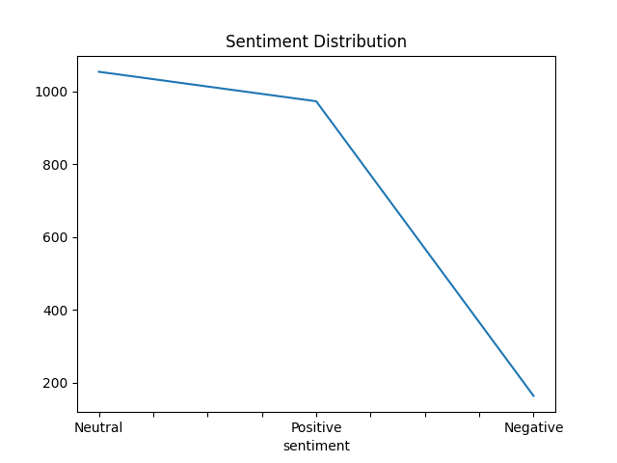

Monthly Sentiment Trend
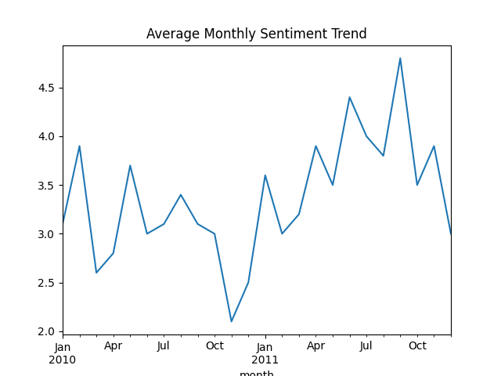

Monthly Top 3 Rankings

2010-01-01
Rank | Positive Employee | Negative Employee
1 | kayne.coulter@enron.com (5) | rhonda.denton@enron.com (0)
2 | patti.thompson@enron.com (5) | johnny.palmer@enron.com (1)
3 | don.baughman@enron.com (4) | bobette.riner@ipgdirect.com (2)

2010-02-01
Rank | Positive Employee | Negative Employee
1 | bobette.riner@ipgdirect.com (7) | lydia.delgado@enron.com (1)
2 | john.arnold@enron.com (7) | patti.thompson@enron.com (1)
3 | don.baughman@enron.com (6) | sally.beck@enron.com (1)

2010-03-01
Rank | Positive Employee | Negative Employee
1 | sally.beck@enron.com (7) | patti.thompson@enron.com (0)
2 | lydia.delgado@enron.com (6) | rhonda.denton@enron.com (0)
3 | bobette.riner@ipgdirect.com (4) | eric.bass@enron.com (1)

2010-04-01
Rank | Positive Employee | Negative Employee
1 | don.baughman@enron.com (5) | eric.bass@enron.com (1)
2 | johnny.palmer@enron.com (4) | patti.thompson@enron.com (1)
3 | rhonda.denton@enron.com (4) | bobette.riner@ipgdirect.com (2)

2010-05-01
Rank | Positive Employee | Negative Employee
1 | don.baughman@enron.com (8) | johnny.palmer@enron.com (0)
2 | patti.thompson@enron.com (7) | bobette.riner@ipgdirect.com (1)
3 | sally.beck@enron.com (6) | john.arnold@enron.com (1)

2010-06-01
Rank | Positive Employee | Negative Employee
1 | don.baughman@enron.com (8) | bobette.riner@ipgdirect.com (0)
2 | patti.thompson@enron.com (6) | eric.bass@enron.com (0)
3 | john.arnold@enron.com (5) | kayne.coulter@enron.com (0)

2010-07-01
Rank | Positive Employee | Negative Employee
1 | lydia.delgado@enron.com (9) | johnny.palmer@enron.com (-1)
2 | bobette.riner@ipgdirect.com (7) | rhonda.denton@enron.com (0)
3 | eric.bass@enron.com (7) | don.baughman@enron.com (1)

2010-08-01
Rank | Positive Employee | Negative Employee
1 | sally.beck@enron.com (12) | bobette.riner@ipgdirect.com (0)
2 | john.arnold@enron.com (5) | eric.bass@enron.com (1)
3 | kayne.coulter@enron.com (4) | patti.thompson@enron.com (1)

2010-09-01
Rank | Positive Employee | Negative Employee
1 | patti.thompson@enron.com (6) | kayne.coulter@enron.com (1)
2 | johnny.palmer@enron.com (4) | don.baughman@enron.com (2)
3 | rhonda.denton@enron.com (4) | lydia.delgado@enron.com (2)

2010-10-01
Rank | Positive Employee | Negative Employee
1 | eric.bass@enron.com (6) | don.baughman@enron.com (0)
2 | john.arnold@enron.com (5) | sally.beck@enron.com (0)
3 | johnny.palmer@enron.com (5) | kayne.coulter@enron.com (1)

2010-11-01
Rank | Positive Employee | Negative Employee
1 | lydia.delgado@enron.com (4) | john.arnold@enron.com (0)
2 | don.baughman@enron.com (3) | rhonda.denton@enron.com (0)
3 | kayne.coulter@enron.com (3) | johnny.palmer@enron.com (1)

2010-12-01
Rank | Positive Employee | Negative Employee
1 | john.arnold@enron.com (8) | bobette.riner@ipgdirect.com (0)
2 | lydia.delgado@enron.com (5) | johnny.palmer@enron.com (0)
3 | sally.beck@enron.com (5) | rhonda.denton@enron.com (0)

2011-01-01
Rank | Positive Employee | Negative Employee
1 | bobette.riner@ipgdirect.com (10) | john.arnold@enron.com (0)
2 | sally.beck@enron.com (6) | kayne.coulter@enron.com (0)
3 | eric.bass@enron.com (5) | patti.thompson@enron.com (1)

2011-02-01
Rank | Positive Employee | Negative Employee
1 | john.arnold@enron.com (10) | rhonda.denton@enron.com (-1)
2 | lydia.delgado@enron.com (7) | bobette.riner@ipgdirect.com (1)
3 | kayne.coulter@enron.com (4) | eric.bass@enron.com (1)

2011-03-01
Rank | Positive Employee | Negative Employee
1 | lydia.delgado@enron.com (7) | sally.beck@enron.com (-1)
2 | bobette.riner@ipgdirect.com (6) | johnny.palmer@enron.com (0)
3 | john.arnold@enron.com (6) | don.baughman@enron.com (2)

2011-04-01
Rank | Positive Employee | Negative Employee
1 | johnny.palmer@enron.com (10) | john.arnold@enron.com (1)
2 | bobette.riner@ipgdirect.com (8) | kayne.coulter@enron.com (1)
3 | eric.bass@enron.com (6) | sally.beck@enron.com (1)

2011-05-01
Rank | Positive Employee | Negative Employee
1 | lydia.delgado@enron.com (8) | patti.thompson@enron.com (-1)
2 | eric.bass@enron.com (6) | bobette.riner@ipgdirect.com (1)
3 | john.arnold@enron.com (6) | kayne.coulter@enron.com (1)

2011-06-01
Rank | Positive Employee | Negative Employee
1 | johnny.palmer@enron.com (13) | kayne.coulter@enron.com (0)
2 | eric.bass@enron.com (8) | don.baughman@enron.com (1)
3 | bobette.riner@ipgdirect.com (5) | rhonda.denton@enron.com (2)

2011-07-01
Rank | Positive Employee | Negative Employee
1 | patti.thompson@enron.com (11) | don.baughman@enron.com (0)
2 | sally.beck@enron.com (11) | kayne.coulter@enron.com (0)
3 | john.arnold@enron.com (6) | lydia.delgado@enron.com (0)

2011-08-01
Rank | Positive Employee | Negative Employee
1 | lydia.delgado@enron.com (8) | kayne.coulter@enron.com (1)
2 | sally.beck@enron.com (6) | rhonda.denton@enron.com (1)
3 | don.baughman@enron.com (5) | bobette.riner@ipgdirect.com (2)

2011-09-01
Rank | Positive Employee | Negative Employee
1 | kayne.coulter@enron.com (9) | john.arnold@enron.com (1)
2 | eric.bass@enron.com (7) | sally.beck@enron.com (1)
3 | rhonda.denton@enron.com (7) | johnny.palmer@enron.com (2)

2011-10-01
Rank | Positive Employee | Negative Employee
1 | lydia.delgado@enron.com (8) | bobette.riner@ipgdirect.com (0)
2 | john.arnold@enron.com (6) | johnny.palmer@enron.com (0)
3 | kayne.coulter@enron.com (6) | rhonda.denton@enron.com (0)

2011-11-01
Rank | Positive Employee | Negative Employee
1 | patti.thompson@enron.com (9) | eric.bass@enron.com (1)
2 | kayne.coulter@enron.com (7) | lydia.delgado@enron.com (1)
3 | bobette.riner@ipgdirect.com (6) | rhonda.denton@enron.com (1)

2011-12-01
Rank | Positive Employee | Negative Employee
1 | kayne.coulter@enron.com (5) | bobette.riner@ipgdirect.com (0)
2 | patti.thompson@enron.com (5) | john.arnold@enron.com (2)
3 | eric.bass@enron.com (4) | johnny.palmer@enron.com (2)

Flight Risk Employees
bobette.riner@ipgdirect.com, john.arnold@enron.com, johnny.palmer@enron.com, lydia.delgado@enron.com, patti.thompson@enron.com, rhonda.denton@enron.com, sally.beck@enron.com

Predictive Model Performance
MSE: 6.969963715342071e-29
R² Score: 1.000

